Architecture Recommendations
Working draft, Draft M24

Business drivers for architectural decisions - “Why” 2
From subject oriented software to process oriented software 4
TODO: Examples of planning for a TO BE state - moving from domain/duplicated functionality implementation - > to general process production using shared services 5
Enterprise data management 6
Reuse and sharing services 7
From legacy technology to SOA and/or cloud 7
Concepts and context - “What” 8
Metadata driven, GSBPM 8
HS:System, service and functionality 11
Clustering of functionalities to services 11
Clustering of services to systems 14
HS:Implementing and encapsulating functionality 14
Cores and adapters 14
Function as a service 15
Containerization 15
Versioning and environments 15
Architectural features for business drivers - “How” 17
Sandboxing for exploration 18
Security 18
Performance 18
Resilient services and error handling 19
Versioning 19
Deployment 19
Containerization 19
Design principles for service autonomy 20
Integration patterns 21
Multilingual support 24
Open source 24
Moving from legacy architecture to service oriented architecture 24
“DOCUMENT WIDE TODOS” 26

Business drivers for architectural decisions - “Why”
Statistical organisations are constantly trying to evolve their IT-systems to better fulfill their business needs or to achieve new business goals. In some cases the drive for change is triggered by external phenomenons such as Big Data/new data sources or the need for higher business agility in order to react more quickly to new user demands. In other cases, it is the technological advancements such as SOA or cloud computing that enables or requires a change in how IT-systems are built. Few business processes, and their supporting IT-systems, live in isolation and therefore the way that these IT-systems are connected is an important consideration in order to keep development and governance costs low and to enable organisations to more quickly change to meet new requirements.

Some of the commonly occurring business drivers within statistical organisations that requires architectural decisions to be made are:
- From subject matter oriented software to shared process oriented software
- Establishing better data management on enterprise level
- Reusing services created by other statistical organisations

Not all statistical organisations focus on all of these business drivers and there could be multiple other important business drivers that should also influence architectural decisions so this document should be seen as a baseline of guidance and not as a complete guidance for architectural decision making.

The concept of architecture in this document involves principles and patterns that allows for a more coherent, consistent approach when designing both IT-systems and the environment that these exist in with the purpose of not only meeting the requirements from the end users but also to enabling the organisation to reach its long term goals. Therefore, this guidance is more focused on what consequences that different patterns can have on the sum of all IT-systems in the organisation and how this in turn supports the long term goals for the organisation.

Making decisions based on architecture rather than technology often means a higher investment cost in the beginning but enables the organisation to reach it’s long term goal. I.e avoiding architecture decisions or making architecture decisions on a case-by-case basis could be efficient in the beginning of these transformations but will over time lead to higher total cost of ownership.

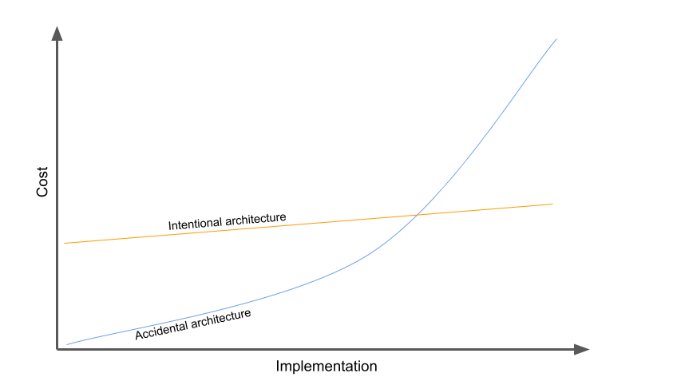
This guidance will support the architecture decisions that are needed for some of the business drivers mentioned above in order to avoid accidental architecture and the long term cost associated with this.

The document builts on CSPA 2.0 but whereas CSPA 2.0 focuses on fulfilling requirements to increase the shareability of services, this document extends the guidance with some of the other commonly occurring business goals. The image below provides a quick overview of how business goals, requirements and features are related.
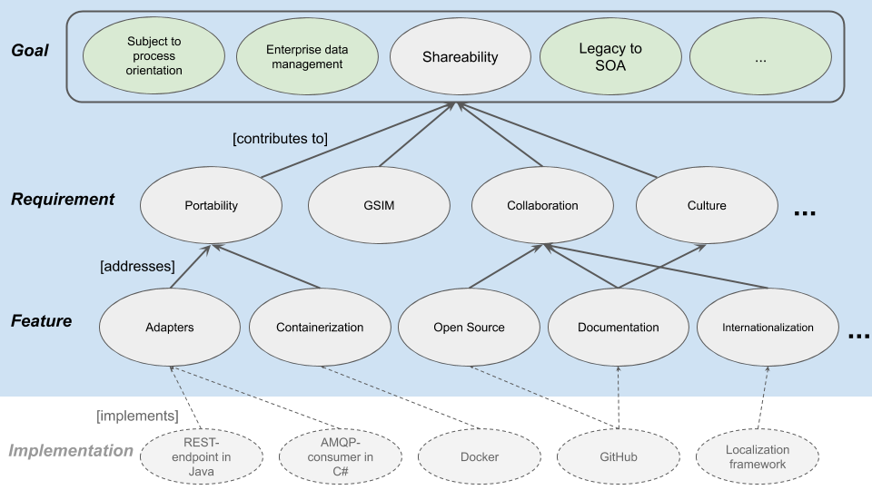
Implementation of architectural features addresses one or more requirements that in turn contribute to one or more business goals.

Target audience for this document
CSPA 2.0 defines 8 different roles that are involved in the application lifecycle management of software for statistical production. This document mainly support the decision making of 4 of them:
- The designer
- The service builder
- The assembler
- The configurer

Most organisations are not organized directly using these roles but instead let existing roles or groups such as CAB:s, it-architects and developers take on the responsibility described by the roles in CSPA. This document is therefore mainly targeted towards architects and developers and is paired together with a more in depth cookbook-document, code examples and an interactive guidance.

Overview of how the different artefacts relate:
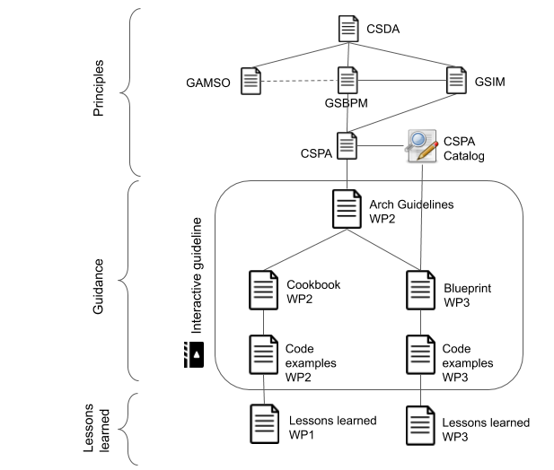

From subject matter oriented software to shared process oriented software
It is a strong tradition in many statistical organisations to build and organise their software based on different subject domains such as Consumer Price Index (CPI), Labour force survey (LFS) and National Accounts (NA). Some have organised their software to support a single statistical output/product such as Quarterly Gross Domestic Product and in some cases software has been built to support a cluster of statistical outputs/products. This has allowed for a very tailored software targeted specifically towards the unique requirements that these have but this also traditionally leads to a somewhat or very heterogeneous IT-environment that is difficult and expensive to maintain.

Since the 90s the concept of business process orientation has had a large impact on many organisations and within the statistical community, the Generic Statistical Business Process Model (GSBPM) has been created and implemented by many statistical organisations. One part of implementation is to focus more on the process perspective rather than the statistical domain when organising software to support statistical production. New software is then created and tailored to support processes such as Error Localisation and Applying disclosure control that can be used for many or all statistical domains (where relevant).

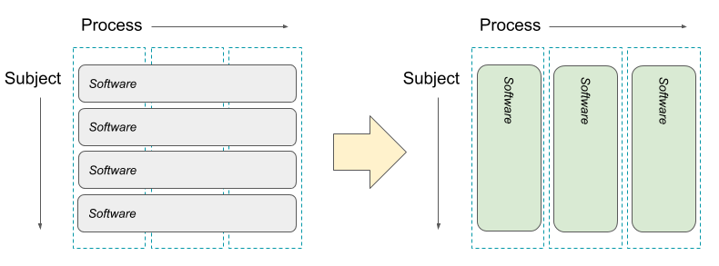
A software created for a specific process rather than a statistical domain needs to be configurable in order to meet the specific requirements that each statistical domain has. For the example of Error Localisation, this could be the set of validation rules that should be used for a specific statistical domain.

A traditional way of developing software for a specific process is to begin with the requirements for a limited set of statistical domains and then adding more configurability for each new set of statistical domains until the software can support more or less all statistical domains. This transition can be seen as going from single-use software to Sharing and Reusing software within one statistical organisation.

The high level goal in this transition is often to reduce the amount of code/software that performs similar types of logic which in turn allows the organisation to make quicker business changes and to reduce the total cost of ownership for the software. However, this new software to business alignment introduces several new requirements significant for the architecture. Some examples:
- Integration - Explicit boundaries between the software supporting the statistical production as a whole, introduces integration needs. Distributed autonomous services often implies decentralized data that has to be exchanged in an efficient way.
- Security - Subject matter / product specific solutions masters its own data created within several process steps is therefore able enforce security and access restrictions globally. Process oriented services need security solutions that support the fact that they handle data belonging to many different information owners / readers..
- Performance and availability - The workload and data volumes can differ considerably between the process oriented services and the product specific solutions. The chosen architecture must address this fact to live up to the performance and availability requirements.

This transition however takes a lot of time for most organisations since it involves both investments to be made to the entire software portfolio as well as changing the perspective for the staff involved in both developing and using the software. For many organisations, the target could also be set to less than a full transition.
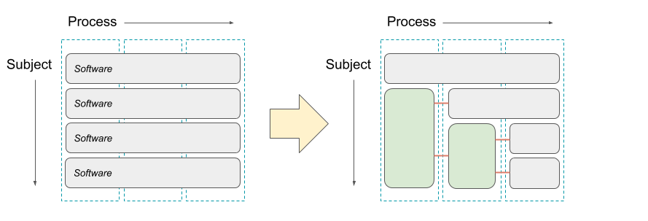

Agile business processes
TODO: Examples of planning for a TO BE state - moving from domain/duplicated functionality implementation - > to general process production using shared services

Enterprise data management
Many statistical organisations implement strategies for better data management on enterprise level. Following the motto of treating data as a high value asset, policies and architecture to support better master data management and going towards more homogeneous data structures is often implemented. Limiting duplicates of data and harmonizing the data structures used to hold the data can make integration between IT-systems easier but going too far towards this could also lead to unwanted effects such as difficulties in updating IT-systems and risks of introducing single point of failures.

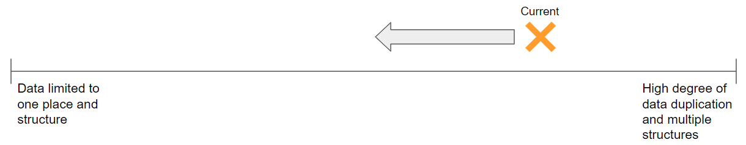

Targeting different points in this spectrum will have consequences on the architecture and how data integration can be structured.

Reuse and sharing services
There are multiple challenges involved with reusing and sharing services. Statistical organisations are different in terms of size, organisation, culture, history, etc. Some other differences, such as technical platforms, can be addressed by architectural decisions. There are solutions such as containerization available to improve the level of portability of a service.

TODO: Different ways of reuse:
- Code / libraries - build, deploy and consume.
- Deployable binaries / packages - deploy and consume.
- “Centrally” deployed runnable services - consume.

TODO: Add deeper discussion on this in the “how part”

Internal sharing:
- TODO:

From legacy technology to SOA and/or cloud
- TODO: Revisit grants submission document to see if this should be included. Where in this document?

HS: Concepts and context - “What”

Metadata driven, GSBPM

GSBPM should not be interpreted as a linear model. The flow of information in the GSBPM often involves processes that are iterative, repetitive and parallel. For example Collection and Processing can be done in parallel. 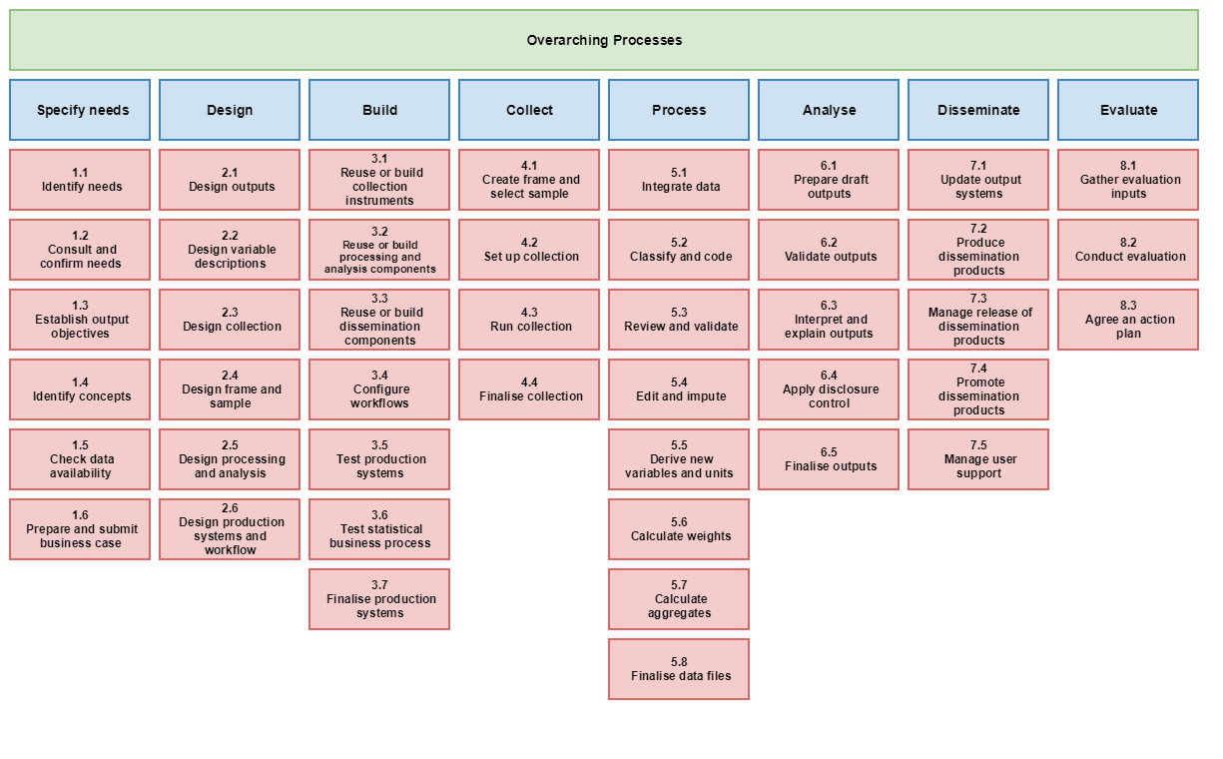
Statistical production from a GSIM-perspective could be seen as a series/network of different types of data creating/processing/manipulation steps. Each step requires different types of GSIM-objects and the result from the step are GSIM-objects that in turn are used by other steps. As shown in the image below we can see how a GSBPM process consumes GSIM structured objects and produces GSIM structured objects.
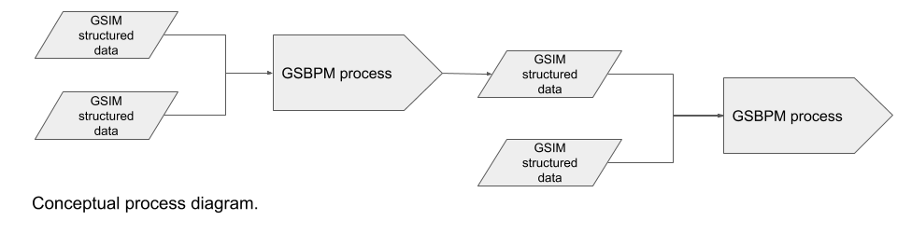
Different names exist for the lower levels of work in statistical production. For steps closer to the GSBPM-phaze Process it will in many cases be a specific method or algorithm that should be performed but for other GSBPM-phazes it could be described as a sub process, an activity or a task. In this document we use the word functionality to describe the conceptual level of these types of steps.

For most process oriented functionalities, the connection to GSIM is described as following: GSIM input -> Functionality -> GSIM output
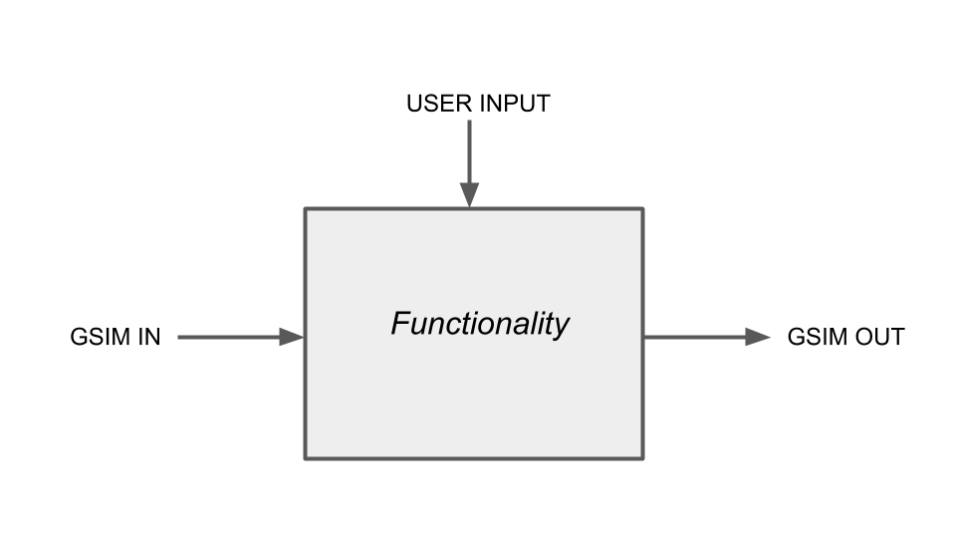
Some functionality can be automated while others involve user interaction. What triggers a functionality can be that some GSIM-information becomes available. For example - the functionality of error localization can be performed automatically after a required Dataset is available. But can also be triggered when a user decides to perform the functionality.

Business functions are accomplished by chaining functionalities that exchange GSIM-objects
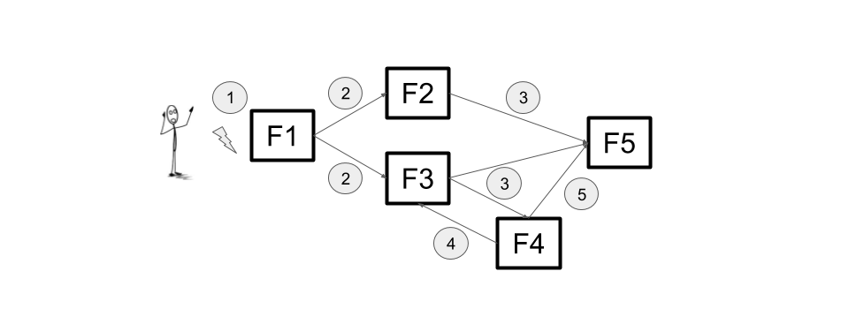
An example of a Business Function as a set of functionalities chained together in a design. In the image above we can see how functionalities are chained in a specific execution order that begins with a manual action and some of the functionalities are executed in parallel.

Statistical programs have different levels of stability in their designs.
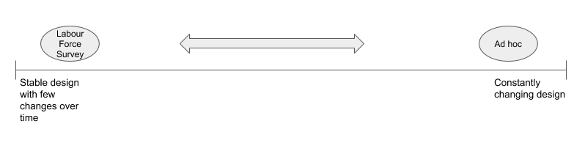
For example in the image above shows how the labour force survey tends to have a more stable design vs ad hoc surveys have a more volatile design.

Beyond functionalities related to GSBPM-processes other types of functionalities are needed to support the production process. Examples of other commonly required functionalities can be functionalities for data storage, graphical user interaction and functionalities for security.

In order to go from the conceptual level of functionality to something technical we need to implement some form of technical implementation. From the CSPA-standard we have a relatively broad definition of Service but later in the document we describe how this document makes use of words such as Services, Systems, Applications, Functions, Code, etc and that they can be seen as different forms or different levels of technical implementations for a Functionality. The sum of the implemented functionalities are what's needed to support statistical production.

System, service and functionality
This document makes use of terms like system, service and functionality. The image below shows the relations between them:
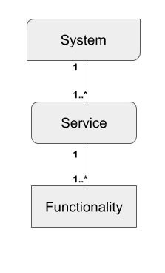
A system can consist of one or several services. A service can consist of one or several functionalities. In the CSPA and TOGAF defines an Application - A deployed and operational IT system that supports business functions and services; for example, a payroll. Applications use data and are supported by multiple technology components but are distinct from the technology components that support the application.
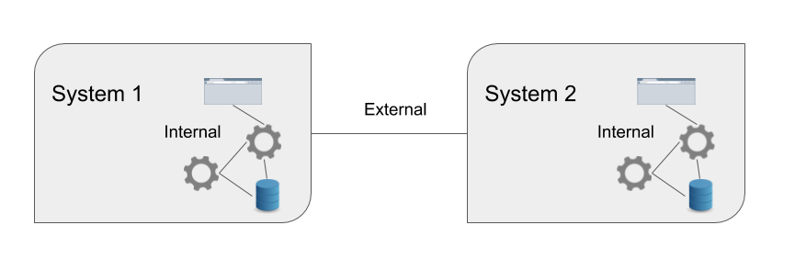
In the coming chapters we will define functionality, service and system.
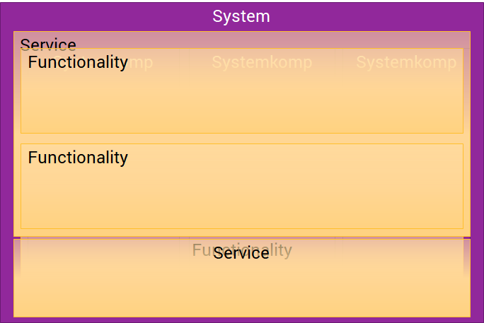

Information and services
The definition of services from CSPA for three types of services: Statistical Function service, Entity service, Utility service. An utility service could be a VTL execution engine. An entity service could be TODO:Example, and a Statistical function service could be error localization.

A service should have a configuration. It should require GSIM input entities and expose GSIM output entities. TODO: Configuration example

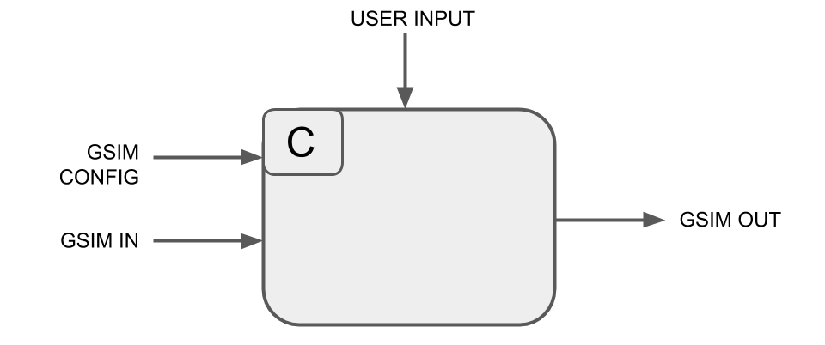

A service often consumes information internally and externally. Some of the information is master information other is secondary information. The external information structure must be GSIM objects but the internal dont have to be.

Enterprise data management involves both managing the physical storage and transportation of information/data as well as managing the structures used to store and carry data.

Clustering of functionalities to services
A service can be composed by a cluster of functionalities as shown in the image below. The image shows the logical view of the information flow. The service in this image is the abstract view:
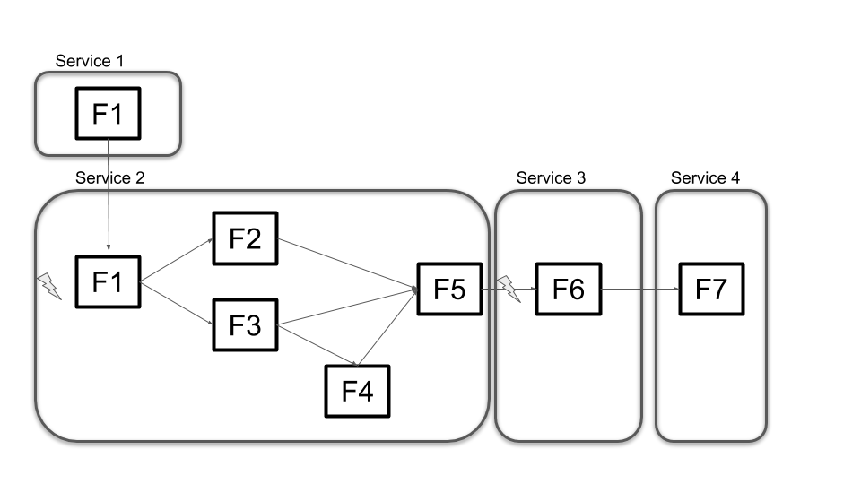
This means that depending on how a system is composed the workflow for the CSPA role configurer can differ depending on the composition of a system. TODO: Exemplify.

Different statistical subject domains/products. Will make use of different combinations of services in order to fulfill their needs. In most cases a service is built explicitly implementing the functionalities that should be part of the service. There are however cases where the service is built in a way that allows for dynamically loading/configuring the functionalities that should be used. in which functionalities TODO: Add discussion about dynamically chained and loaded functionality within a service vs chained and executed functionality in other services.Clustering of services to systems
A system can be composed of multiple services. Systems can also consist of UI, storage and integration points.
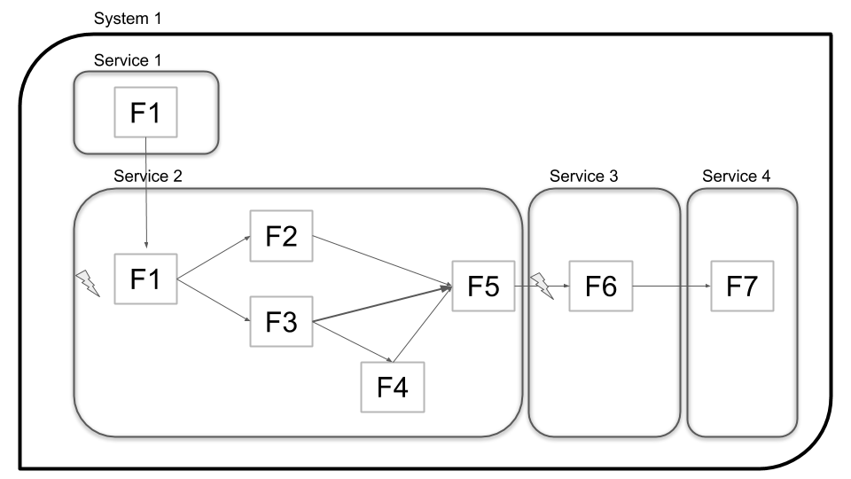

A system is master of its own information. The concept of system is encapsulation of masterdata.

Implementing functionality
A functionality must be implemented in some technical framework(.Net core, R, Neo4J). A functionality will also be encapsulated in different architectural styles like Ports and adaptors also known as Hexagonal Architecture. For more information on Ports and adaptors please see the chapter:CSPA TODO: Add link
Functionality can also be implemented for use in runtime or in compile time.

Function as a service
When thinking about how the functions and services should be implemented some considerations should be made on how the service is going to be deployed. Function as a service means that you can define a function without provisioning an entire system.

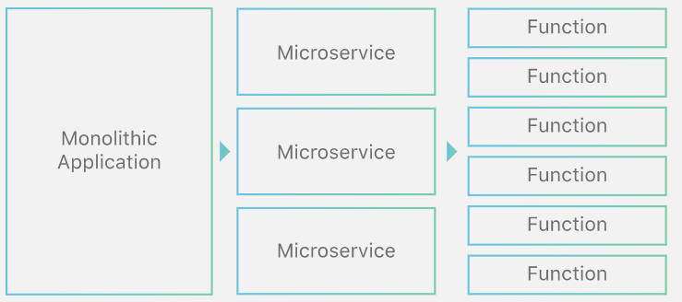

The implementation can vary depending on where it is deployed and functions can be written in different languages and hosted in different environments.
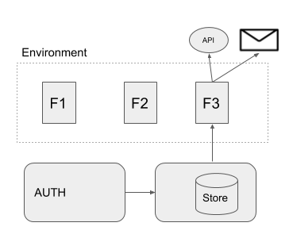
In the image above functions are deployed as code. Function 3 pulls data from a datastore service and when it is finished it calls a rest api and a mail service.

TODO: add reference to serverless/function as a service

Containerization
A container is a standard unit of software that packages up code and all its dependencies so the application runs quickly and reliably from one computing environment to another. A container image is a lightweight, standalone, executable package of software that includes everything needed to run an application: code, runtime, system tools, system libraries and settings. How containers are composed depends on what the goal is to achieve with the containerization.

System context, environments and versioning
Systems can be used within different contexts. A common context is the ALM-perspective, development, test and production. All contexts may require different environments. Within the production environment a system can also exist in different business contexts like different statistical programs or statistical cycles. This context can be deployed programmatically or in runtime.
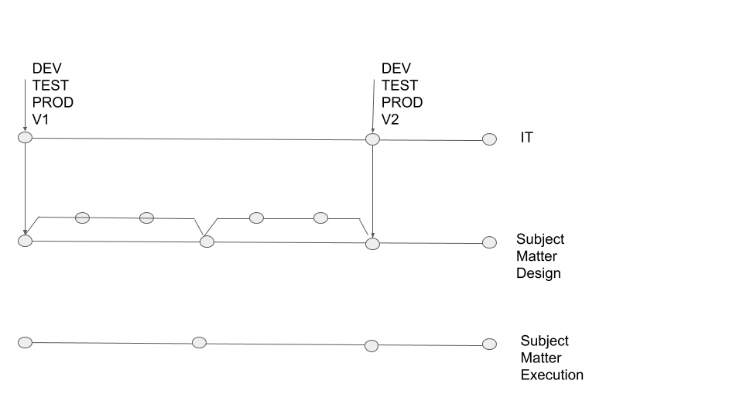
Different environments could be created for production to separate the business contexts. The purpose for creating different environments could be due to performance, security, easy versioning of systems, keeping production environments sanitized with regards to old data/information etc. Here are some different approaches to setting up environments/systems:

- Option 1 - All Statistical Programs run in the same environments - the same system instance is used by all Statistical Programs
- Option 2 - Manually creating different environments for different Statistical Programs or Statistical Program Cycles
- Option 3 - Automatically generating environments or instances of systems based when a new Statistical Program or statistical program cycle is created
- Option 4 - Continuous integration/Continuous Deployment or deploying functions

A system can exist in different versions in different production environments. TODO: Add image showing this.

Architectural features for business drivers - “How”

An architectural feature is a high level solution for addressing one or many requirements. The target requirements for this document are derived from the business drivers above. The term feature is reused from CSPA 2.0 Application Architecture, which also includes many of the features stated here.

Features can be implemented in many different layers using different kinds of solutions. The purpose of this chapter is to try to give input to the process of choosing a solution as well as pros and cons of solving the problem in one layer or another.
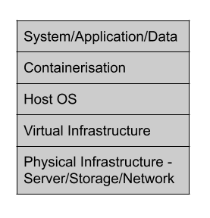

Sandboxing for exploration
Outline for chapter:
- Chapter is not directly architecture but is worth mentioning.
- TODO: Sandboxing for “turning the knobs” as a different chapter? Or broaden this...

Security
Outline for chapter:
- There are many ways to handle security. Discuss how security can be implemented in different layers.
- Zero trust can be implemented in different ways. Data at rest, data in transit.
- Capability based security (Tokenbased)
- Mandatory Access Control (MAC)
- Authentication Before Application
- Boundaries for container style
- Describe security from the perspective of CSPA roles, configurer och user.

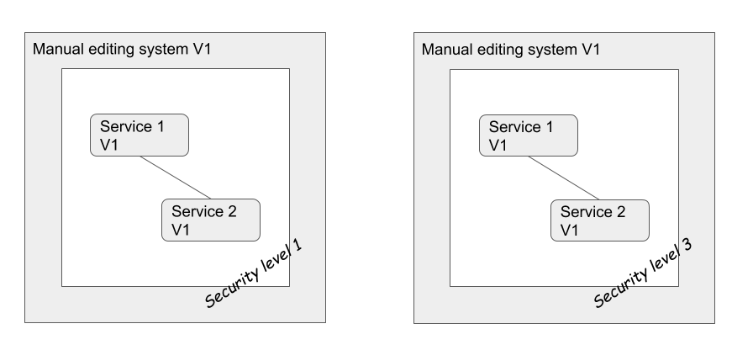

Performance
The contexts in which a service is consumed are very diverse. Parameters such as number of users, data size and load will vary a lot.

Scaling
Scaling is the process of making software more capable of handling increased capacity and availability. A common way of defining different scalability solutions is the three dimensional cube model:

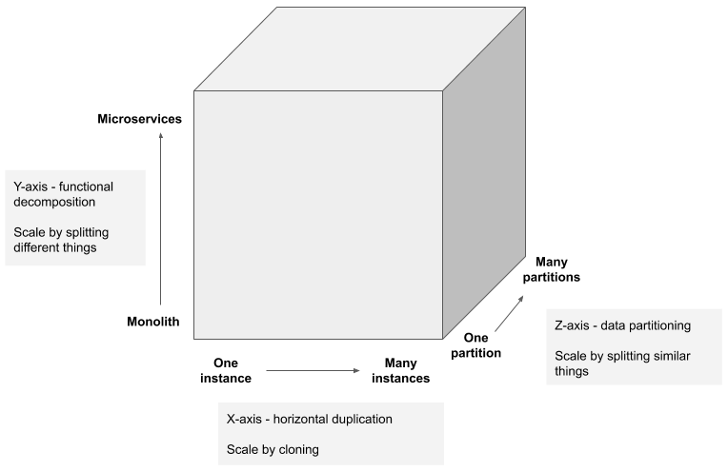

X-axis scaling load balances requests across multiple identical instances of a system in order to distribute work.

Y-axis scaling is about decomposing a system into multiple different services where each service is responsible for a group of closely related functions.

Z-axis scaling is often combined with X-axis scaling and adds the capability to make each instance of a system responsible for a subset of the data based on some routing rule. This approach is commonly used when scaling databases.

Considerations driven by business drivers:
 | X | Y | Z
From subject oriented software to process oriented software | Increased workload and data volumes will require scaling capabilities. X-axis as well as Z-axis scaling will be fundamental to fulfill the availability and performance requirements. | Very beneficial solution when process orienting the software. Functions supporting different parts of the processes are supported by different services. The granularity of the services will differ but still be supporting a part of a process instead of being hard coded to a specific subject. | See X.  Consider the current context to be used for routing rules. For example, the data persistence layer could be partitioned in alignment with the different Statistical Programs.
Enterprise data management | Not specifically, but X-axis scaling is almost always applicable. | Storage solutions with high data volumes and increased number of consumers needs extensive scaling.
Reuse and sharing services | Workload and data volumes will differ among potential consumers of a service. Scaling solutions are important to support. | Services with limited functionality are easily shared. Y-axis scaling is inferred. | See X.
From legacy technology to SOA and/or cloud | Service orientation principles such as loose coupling and standardized service contract simplifies the implementation of all of these scaling solutions.  Scaling solutions like these are fundamental promises of all cloud computing platforms.

Resilient services and error handling
For a service to be attractive and reusable it must implement a decent level of fault tolerance and recoverability.

Fault tolerance
In the event of an interruption, temporal high latency or a failure it can to some degree still be possible for the service to operate as intended. Failure due to underlying blocking calls could be handled by solutions such as the Circuit Breaker pattern to effectively prevent running out of critical resources such as memory and threads.

Failure due internal faults must always be handled and logged to enable troubleshooting, correction of errors and other improvements.

https://iso25000.com/index.php/en/iso-25000-standards/iso-25010?limit=3&start=3

https://martinfowler.com/bliki/CircuitBreaker.html
https://microservices.io/patterns/reliability/circuit-breaker.html

Recoverability
Degree to which, in the event of an interruption or a failure, a product or system can recover the data directly affected and re-establish the desired state of the system

Outline for chapter:
- A runnable service must be able to handle internal crashes and should have functionality to recover from a crash where applicable.

Degree to which, in the event of an interruption or a failure, a product or system can recover the data directly affected and re-establish the desired state of the system

- TODO: Status monitoring and logging

Chaos monkey

Versioning
Versioning has different meaning in different contexts:

Service versioning
Versioning of code, binaries?

Endpoint versioning
TODO

GSIM structure versioning
TODO

Information object instance versioning
TODO

Deployment
Outline for chapter:
- In this chapter we will summarise the features above. We will describe different types of deployment that supports different requirements and features. Refer to the work from WP1 that norway have done.

Containerization
Outline for chapter:
- Describe how containerization can help us to achieve some of the non functional requirements.

Design principles for service autonomy
Outline for chapter:
- Have a discussion about some of the key principles for service autonomy and shareability.

Data management
Adherence to GSIM
- Internal / external representation

Integration patterns
Outline for chapter:

- Information flow patterns as input to architectural discussions
  - Sequencing of processes
  - One-to-many, One-to-one
  - Timing and parallelism
  - Iterative, repetitive, partial/full information, schedule basis
  - Context bound information

TODO: Image with chosen example services. Describe briefly each service - reuse appendix from Wiessbaden.

A total view of all integrations required for production services. 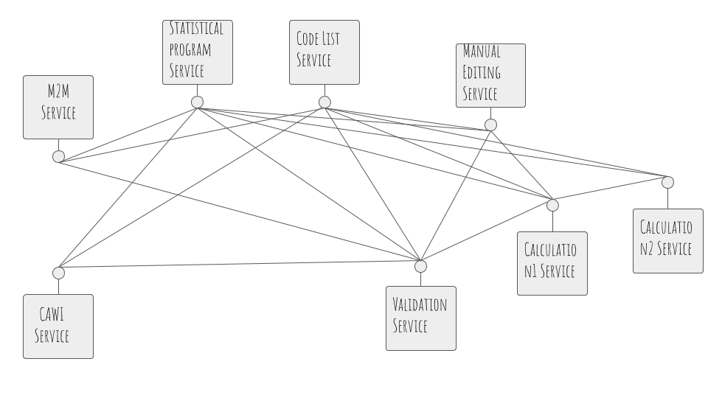
Metadata services can often benefit of asynchronous communication patterns. In the image below the metadata integrations are dotted. In the image we have the statistical program service and det code list service that are metadata services.
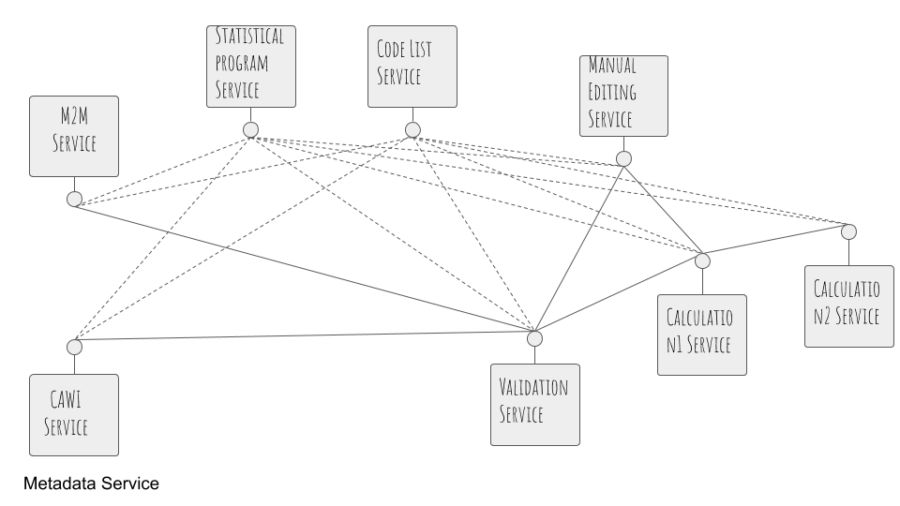
Some of the service benefits of an event driven approach. The image below is showing how the collection services can benefit of an event driven approach. But the calculation services maybe don't.

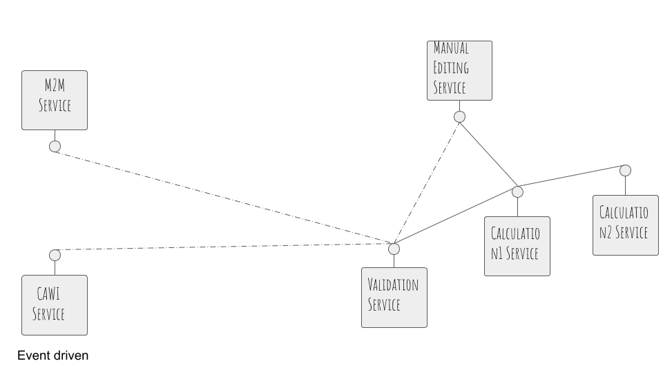

In a production environment different types of integrations will be used.
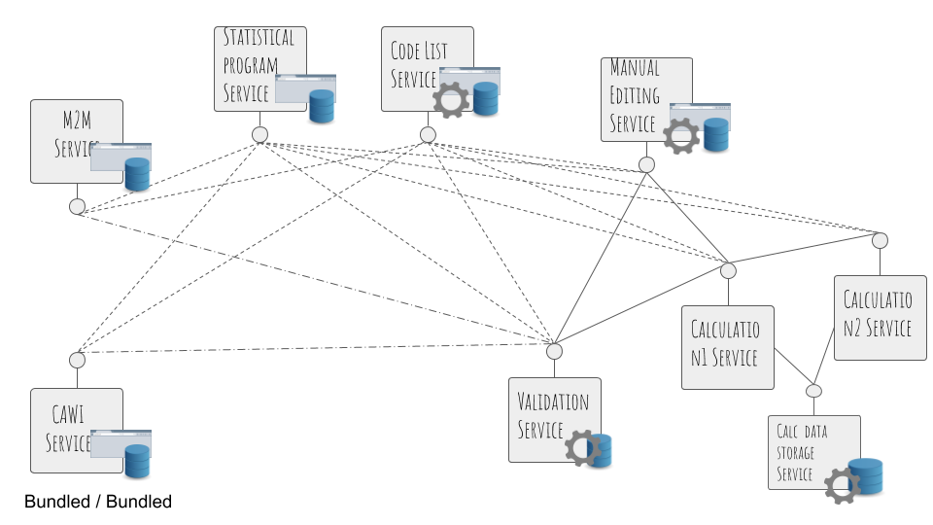

- TODO: Scale: From “Data only once” ------ “Data everywhere”
  - Left pros: Enterprise data, security
  - Right pros: Availability
- Bundled reference data vs unbundled.
- “Storage is not a solution for integration”

Solutions:
- Point to point, event driven, orchestration
  - TODO: Images
- Multiple instances of services

TODO: Redraw matrix below
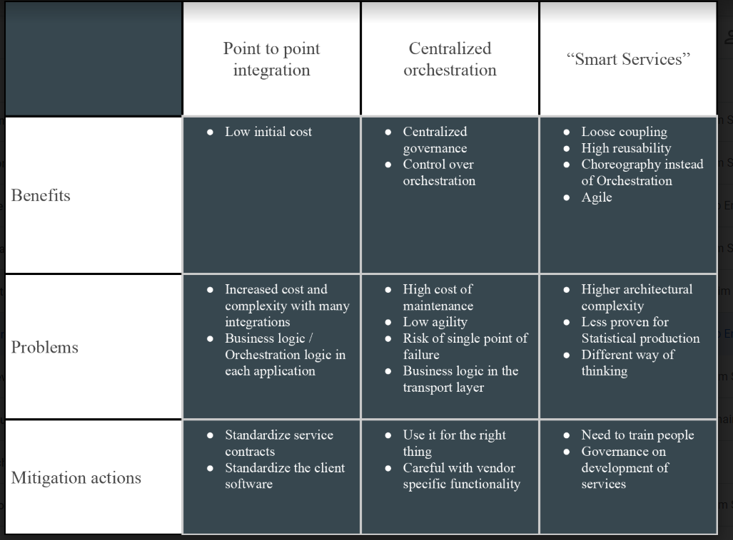

Multilingual support
Outline for chapter:
- Chapter is not directly architecture but is worth mentioning.

Open source
Outline for chapter:
- Chapter is not directly architecture but is worth mentioning.

Moving from legacy architecture to service oriented architecture
Outline for chapter:
- Selective decomposition.
- Enable release of information ownership.

